Thang Tran – 6113753
Deepak Chandrashekar - 6614493

E-Shopping System (ESS)
Software Requirements Specification Document

Version: (1) Date: (02/07/2013)

Table of Contents

1. Introduction 4
1.1 Purpose 4
1.2 Scope 4
1.3 Definitions, Acronyms, and Abbreviations. 5
1.4 References 5
1.5 Overview 5
2. The Overall Description 6
2.1 Product Perspective 6
2.1.1 System Interfaces 6
2.1.2 Interfaces 6
2.1.3 Hardware Interfaces 6
2.1.4 Software Interfaces 6
2.1.5 Communications Interfaces 6
2.1.6 Memory Constraints 6
2.1.7 Operations 6
2.1.8 Site Adaptation Requirements 7
2.2 Product Functions 7
2.3 User Characteristics 7
2.4 Constraints 7
2.5 Assumptions and Dependencies 8
2.6 Apportioning of Requirements. 8
4.Change Management Process 16
5.Document Approvals 16
6.Supporting Information 17

1. Introduction

The e-shopping system (ESS) provides a user friendly interface for customers to seamlessly purchase a variety range of products.

1.1 Purpose

The purpose of this SRS document is to provide requirements and functionality of the Online shopping web application we are building. This document will be a reference document for design documents such as system design, software design and testing plans.

This SRS describes only functional and non-functional requirements but does not provide design suggestions. The main objective of this document is that it provides a contract between developers and the client that they share same understanding of what is required, what needs to be done and what to be delivered.

1.2 Scope

Initial functional requirments designed to allow a user to perfrom the following functions:
- To Securely register and manage profile for Customers.
- The system will allow the customer to browse, search, select, add item to their cart, to select shipping method, to checkout and track their product(s).
- Strategic data and graphs for Administrators and Shop owners about the items that are popular in each category and age group.
- To support feedback mechanism, so that customers can give feedback for the product or service which they have purchased. Also facility rating of individual products by relevant customers.
- Adequate payment mechanism and gateway for all popular debit/credit cards.
- The system will allow the admin(owner) to add or delete the products and to update the product related information like description, price, etc.
- To provide email confirmation for successful order completetion and to get the receipt.

Non-functional requirments:

- Regular updates to registered customers of the new arrivals.

- To advertise/display “The Most Popular” items in each category of products.

- Sending promotion emails to all subscribed customer (members)

1.3 Definitions, Acronyms, and Abbreviations.

Terminology | Description
Admin/ Manager | A person who can add/delete or edit the product information.
Barcode | A unique identifier for each item
Checkout | The process a Customer purchasing the item(s)
Item | A product available for sale
Customer/Client | A person who has an account and can purchase a product online
Promotion | A discount of a selected product
Session | The time which a User is actively using the system
Shopping Cart | The collection of item(s) that the client has selected and can be checkout
SRS | Software Requirment Specification
Stock | A number representing the remaining item(s) for a specific product type
Transaction | The information related to a customer's purchase that is logged
ESS | e-shopping System

1.4 References
- IEEE Guide to Software Requirements Specifications (Std 830-1993)
- http://techwhirl.com/writing-software-requirements-specifications
- http://en.wikipedia.org/wiki/E-commerce
- www.amazon.com
- www.newegg.com

1.5 Overview

In this subsection:
- Describe what the rest of the SRS contains
- Explain how the SRS is organized

Don’t rehash the table of contents here. Point people to the parts of the document they are most concerned with. Customers/potential users care about section 2, developers care about section 3.

2. The Overall Description
The e-shopping system (ESS) provides a user friendly interface for customers to browse, and purchase a variety range of products. The user no need to login to browse the products. But user must login to buy the products. The user can register for promotions and updates. Any user who has basic knowledge of Internet and browsers can use e-shopping system.

2.1 Product Perspective
The ESS aims to provide a online purchasing system, which is well-planned, smooth and as automated as possible. ESS is intended to be a stand-alone website, which can be managed both locally or from distance and also browsable from all popular web browsers like Internet Explorer, Google Chrome, etc. The system allows the customers with many options like debit or credit securedly payments or viewing the product feedback and recommendations. There are no specific requirements for customers in terms of software or hardware.

2.1.1 System Interfaces

N/A

2.1.2 Interfaces

N/A

2.1.3 Hardware Interfaces

N/A

2.1.4 Software Interfaces

N/A

2.1.5 Communications Interfaces

N/A

2.1.6 Memory Constraints

N/A

2.1.7 Operations

N/A

2.1.8 Site Adaptation Requirements

N/A

2.2 Product Functions

- Admin/Manager
The manager (admin) has complete control over all activities that can be performed:
- Add/delete new product categories, product types, product items
- Modify the stock info, product prices, product specifications
- View transaction logs.
- Login and logout of the system
- View auto-generated sale reports (saleline report for each product types, etc.)
- View and reply to customers feedback and suggestions.

- Guest
- Can sign up for a new user account
- Browse and search products under each category
- View ratings and comments about each products.

- Registered clients/customers
In addition to all the function that a guest to do, a registered client can also:
- Login and logout of the system
- Review and checkout the shopping cart.
- Track the order processing, and cancel any order that has not been shipped.
- Subscribe/unsubscribe to receive promotion emails
- Give feedback and rate the products
- Modify certain information in their user profiles.
- Logined client can add or remove product items from the shopping cart
- Add bank account information (debit/credit) to their user account.

- System functions
- ESS system maintains database of items, collection of items for each product types and collection of product types for each categories
- The system maintains database of customer username, passwords, email addresses, postal addresses and bank account information.
- The system maintains daily log of all proceeded transactions.

2.3 User Characteristics

- The user should be familiar with some terminologies like credit cards, debit cards, checkout process, shopping cart, shipping methods.
- The user must have a basic background of computer, Internet and browsers.

2.4 Constraints

- New user can only register with username and password follow some specific formats. To be specific, username and passwords must meet a number of conditions – as following: Username should be between 6 to 20 characters, with no special characters and white spaces; Password must have both letters and numeric characters.
- The recommended browser to be used should be either Firefox, IE8, Chrome. There is no guarantee that the system can work well under other browsers.

2.5 Assumptions and Dependencies

• The details related to the product, customer, payment and service transaction provided manually.
• Administrator or manager account is hardcoded
• Users cannot change their username, once registration is complete.

2.6 Apportioning of Requirements.

N/A

3. Specific Requirements
3.1 External Actor Descriptions
There is no hardware or software actors. All external actors are illustrated in the use case diagram bellows:
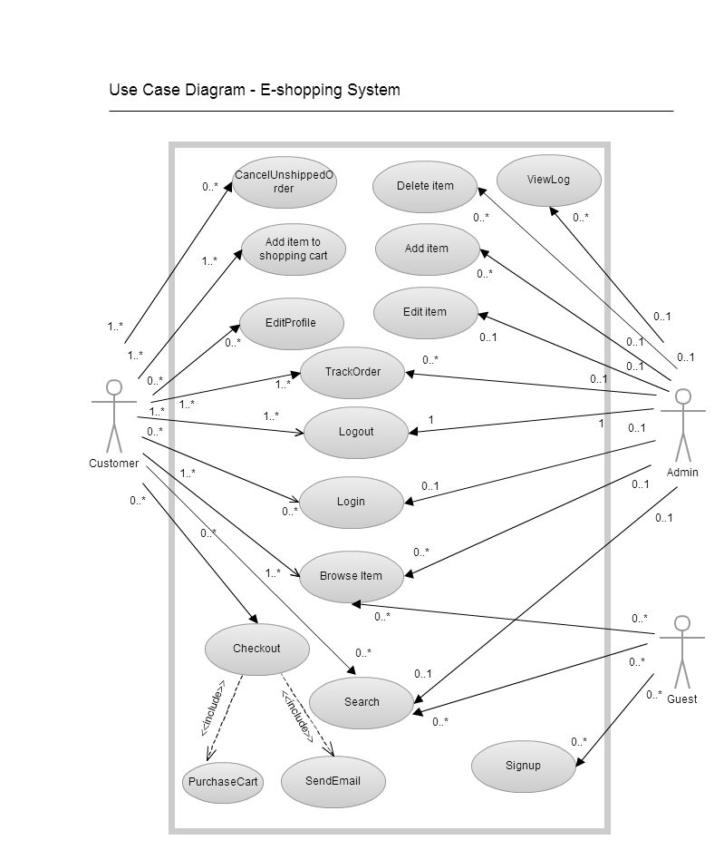
3.2 Use Case Descriptions
3.2.1 Add Item to Shopping Cart
Use Case ID: UC-1
Use Case: Add Item to Shopping Cart
Primary Actors: RegisteredCustomer
Pre-conditions: Customers who successfully logged in
Post-conditions: Item with barcode is added to the cart
Description: Allows registered customers to add their selected items to their respective shopping cards
Includes: None
Main Success Scenario:
1. RegisteredCustomer selects the number of the choose items
2. RegisteredCustomer clicks the button “Add to Shopping Cart”.
3. System displays “Items added successfully”
Extentions:
1. The current quantity of item is less than the requested number, use case ends in failure

3.2.2 Login
Use Case ID: UC-2
Use Case: Login
Primary Actors: Customer, Admin
Pre-conditions: None
Post-conditions: Loggin successfully and previleges are given properly.
Description: Allows users to loggined into their respective accounts
Includes: None
Main Success Scenario:
1. Customer or Admin enter their usernames and passwords into the corresponding textboxes
2. Customer or Admin click the button “Login”
3. System redirects the users to the new interface for loggined users.
Extentions:
1. Username or password is unmatched, use case ends in failure

3.2.3 Logout
Use Case ID: UC-3
Use Case: Logout
Primary Actors: Customer, Admin
Pre-conditions: None
Post-conditions: Loggout successfully and all actors become “Guest”
Description: Allows users to log out of their corresponding account
Main Success Scenario:
1. Customer or Admin click the button “Logout”.
2. System displays “Loggout succeeded”.
Extentions:
None

3.2.4 BrowseItem
Use Case ID: UC-4
Use Case: BrowseItem
Primary Actors: Customer, Admin, Guest
Pre-conditions: None
Post-conditions: New layout of choosen product type/item/category appear
Description: Allows registered users or guests to browse the website to navigate for items, types or categories
Main Success Scenario:
1. Any mentioned actors click on the product type/category/item hightlighted link
2. System display the corresponding page for item/type/category.
Extentions:
None

3.2.5 Search
Use Case ID: UC-5
Use Case: Search
Primary Actors: Customer, Admin, Guest
Pre-conditions: None
Post-conditions: List of mathed items are displayed
Description: Allows users and guests to search for items
Main Success Scenario:
1. Any actor enters the incomplete or complete name of item into the textbox.
2. Actor can choose a specific category or product type, to search more specifically.
3. Actor click the “Search” button.
4. System display the list of matched results
Extentions:
1. There is no matched result to be displayed, use case end in failure

3.2.6 TrackOrder
Use Case ID: UC-6
Use Case: TrackOrder
Primary Actors: Customer, Admin
Pre-conditions: All actors must be registered users.
Post-conditions: Items shipping or processing status is displayed
Description: Allows registered user to track an order based on orderID
Main Success Scenario:
1. Actor clicks to hyperlink of “TrackingOrder”
2. Actor enters the Order Id into the textbox
3. Actor click the “Track” button.
4. System displays the status of the corresponding items
Extentions:
1. OrderID is not existing in the system, display “OrderID is incorrect”, use case ends in failure.

3.2.7 Signup
Use Case ID: UC-7
Use Case: Signup
Primary Actors: Guest
Pre-conditions: None
Post-conditions: A new user account is created, an email comfirmation is dispatched to the customer’s registered email address.
Description: Allows guest to register for a unique new account
Main Success Scenario:
1. Guest clicks at the “Signup” button
2. System redirects the Guest to a new page with signup information
3. Guest enters his/her information (username, password, email address, postal address, first name, last name)
4. Guest clicks “Done”
5. Systems display the message “Signup successfully, please loggin now”
Extentions:
1. The username is already in used, ask the guest to refill the form
2. The username or password does not follow the rules, ask the guest to refill the form
3. One of the text fields is not filled up, ask the guest to refill the form

3.2.8 EditProfile
Use Case ID: UC-8
Use Case: EditProfile
Primary Actors: Customer
Pre-conditions: Customer is already logged in into the system.
Post-conditions: New user information is updated to the database.
Description: Allows registered customer to edit certain information in their profile. Username is immutable.
Main Success Scenario:
1. Customer clicks on the “Edit Profile” hyperlink.
2. Actor choose the criteria (postal address, email address, password)
2’. Actor can also add new banking account (debit or credit account)
3. Actor enters the current password into the text box
4. Actor click “Comfirm” button
Extentions:
1. New password (if changed) does not abide the rules, ask the customer to refill the form
2. Email address is not properly formatted, ask the customer to refill the form.
3. New banking account (if added or modified) is not valid, display notification, use case ends in failure.

3.2.9 CancelUnshippedOrder
Use Case ID: UC-9
Use Case: CancelUnshippedOrder
Primary Actors: Customer
Pre-conditions: Customer has already logged in into the system.
Post-conditions: Order status changes to “Order was canceled successfully. Refund will be credited back the original account”
Description: Allows customers to cancel unshipped orders.
Main Success Scenario:
1. Customer click on the “cancel unshipped orders” hyperlink
2. System displays the list of unshipped orders belong to that customer
3. Actor select the checkbox of the corresponding order, that he wants to cancel
4. Actor click the “Comfirm Cancel Order” button.
5. System displays succeed
Extentions:
1. Actor selects “Cancel”, system redirect to the previous page. No Order is cancelled.
2. There is no available “unshippedOrder”, so nothing can be cancelled.

3.2.10 Checkout
Use Case ID: UC-10
Use Case: Checkout
Primary Actors: Customer
Pre-conditions: Customer already logged in into the system.
Post-conditions: System display order succeeded, email confirmation is sent.
Description: Allows customer to purchase for the items in their shopping cart.
Includes: SendEmail, PurchaseCart.
Main Success Scenario:
1. Customer clicks on the “Checkout” button
2. System redirect the customer to Payment page, and display to total balance
3. PurchaseCart Use Case
4. SendEmail Use Case
5. System display “Order successful” , update the database. Put the order into the processing queue.
Extentions:
1. Customers’ credit is not enough to pay, or the credit info is not valid, use case ends in failure.
2. Customers click “Cancel” in any of those above steps, use case ends in failure.

3.2.11 AddItem
Use Case ID: UC-11
Use Case: AddItem
Primary Actors: Admin
Pre-conditions: Admin already logged in into the system.
Post-conditions: New item is added, and displayed into the website
Description: Allows the admin to add a new item into an existed product type, or creating a new product type/category for the new item.
Main Success Scenario:
1. Admin click on the “AddNewItem” button
2. System redirect the admin to a new page
3. Admin enter the item’s name, quantity, select or enter a new product type/category, item’s price, item’s vendor name, etc.
4. System updates the database and display successful notification
Extentions:
None.

3.2.12 DeleteItem
Use Case ID: UC-12
Use Case: DeleteItem
Primary Actors: Admin
Pre-conditions: Admin already logged in into the system.
Post-conditions: Item is deleted successfully, database is updated.
Description: Allows the admin to delete an existing item, along with all of its quantity and its information.
Main Success Scenario:
1. Admin click on the “DeleteItem” button
2. System redirect the admin to the corresponding page
3. Admin enter the item ID, and click “Delete”
4. System displays a successful notification.
Extentions:
1. ItemID is not valid, use case ends in failure

3.2.13 EditItem
Use Case ID: UC-13
Use Case: EditItem
Primary Actors: Admin
Pre-conditions: Admin already logged in into the system.
Post-conditions: Item is editted successfully, database is updated.
Description: Allows the admin to edit the current quantity, and all related item’s information.
Main Success Scenario:
1. Admin click on the “EditItem” button
2. System redirect the admin to the corresponding page
3. Admin enter the item ID, and click “Edit”.
4. Admin change the item info form.
5. Admin clicks the “Submitted” button
6. System display successful notification
Extentions:
1. ItemID is not valid, use case ends in failure

3.2.14 ViewLog
Use Case ID: UC-14
Use Case: ViewLog
Primary Actors: Admin
Pre-conditions: Admin already logged in into the system.
Post-conditions: Display all transaction and order logs.
Description: Allows the admin to view transaction logs of the day.
Main Success Scenario:
1. Admin click on the “ViewLog” hyperlink
2. System redirect the admin to the corresponding page
3. Admin views transaction and order logs.
Extentions:
None

3.2.15 PurchaseCart
Use Case ID: UC-15
Use Case: PurchaseCart
Primary Actors: Customer
Pre-conditions: Customer already logged in into the system.
Post-conditions: System update the transaction logs
Description: Allows the admin to edit the current quantity, and all related item’s information.
Main Success Scenario:
1. Customer choose a payment method (debit/credit) or use the already linked bank account.
2. Customer click “Payment Confirmation” button.
Extentions:
1. Bank account info is not valid, or the credit available is not sufficient. Use case ends in failure. System displays “Unsuccessful Transaction”.

3.2.16 SendEmail
Use Case ID: UC-16
Use Case: SendEmail
Primary Actors: Customer
Pre-conditions: Customer already logged in into the system.
Post-conditions: Email is sent to the customer’s email address
Description: Allows the customer to receive email confirmation and invoices
Main Success Scenario:
1. System generate the receipt and send to the corresponding customer’s email address.
Extentions:
1. Email is not valid, use case ends in failure.

Change Management Process

N/A

Document Approvals
N/A

